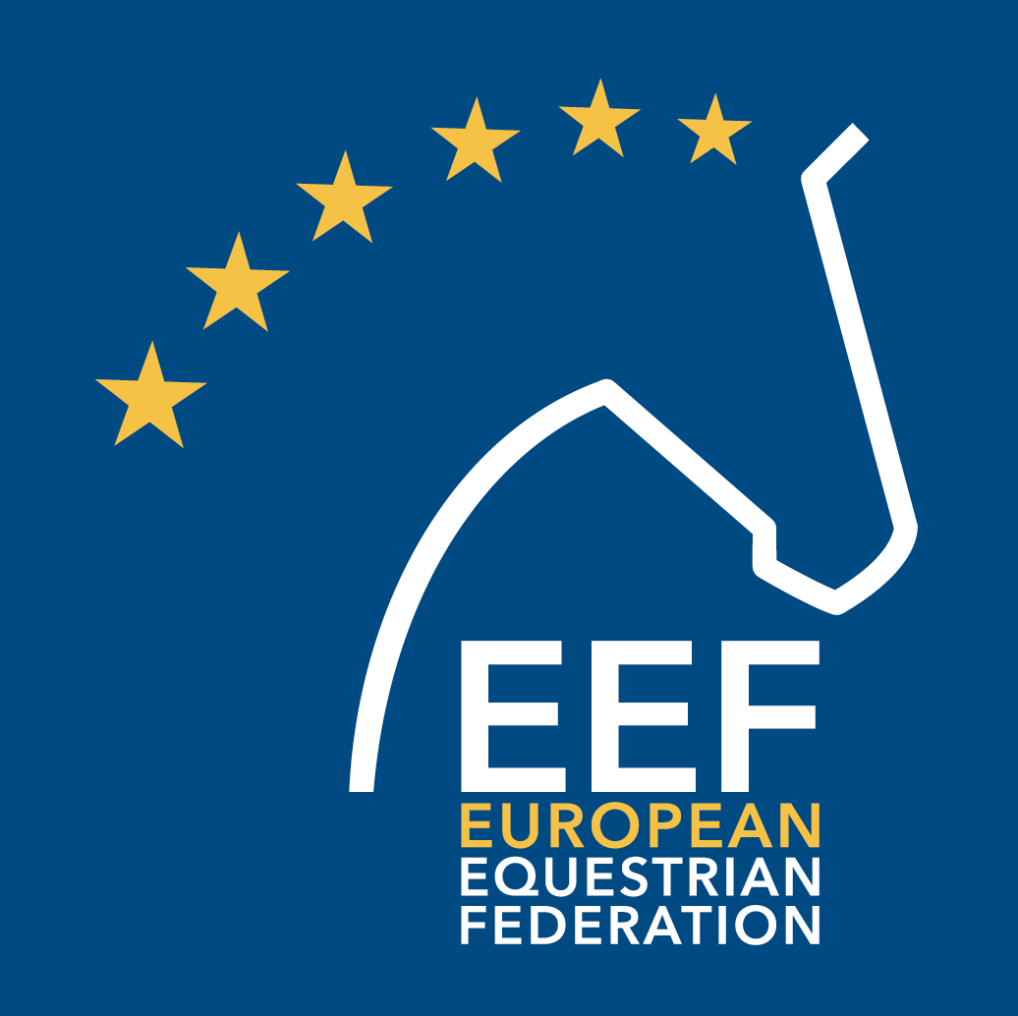

European Equestrian Federation

ATTENDANCE FORM

2022 EEF GENERAL ASSEMBLY
12 September 2022 in Warsaw (POL)

Name of organization (NF / stakeholder) Click or tap here to enter text.
Name of delegate Click or tap here to enter text.
Name of accompanying person (if applicable) Click or tap here to enter text.

Please indicate whether you will be attending the following social events connected with the 2022 EEF General Assembly
Longines EEF Series Final
Guided tour to visit Warsaw Old Town and The Royal Castle
Gala dinner hosted by the POL NF

If you wish to make a room reservation at the Hotel Warszawa, kindly provide the following information:
Number of rooms Click or tap here to enter text.
Type of room(s) (Single/Junior Suite/Suite) Click or tap here to enter text.
Dates (from / to) Click or tap here to enter text.
Name(s) of guest(s) Click or tap here to enter text.

Kindly return the completed attendance form to carina.mayer@euroequestrian.eu
by 19 August 2022.

